**Finance Analysis**

**Introduction**

You are a Finance Analyst working for 'The Big Bank'

You have been tasked with finding out about your customers and their banking behaviour. Examine the accounts they hold and the type of transactions they make to develop greater insight into your customers.

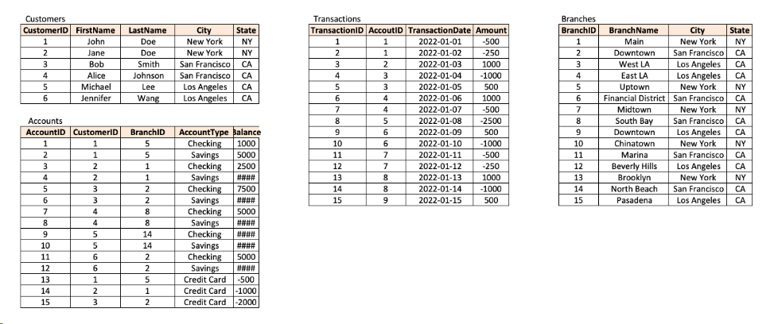

**Questions**

**Answer the following questions**

1. What are the names of all the customers who live in New York?

2. What is the total number of accounts in the Accounts table?

3. What is the total balance of all checking accounts?

4. What is the total balance of all accounts associated with customers who live in Los Angeles?

5. Which branch has the highest average account balance?

6. Which customer has the highest current balance in their accounts?

7. Which customer has made the most transactions in the Transactions table?

8.Which branch has the highest total balance across all of its accounts?

9. Which customer has the highest total balance across all of their accounts, including savings and checking accounts?

10. Which branch has the highest number of transactions in the Transactions table?

**DDL & DML commands.**

-- Create the Customers table

CREATE TABLE Customers (

CustomerID INT PRIMARY KEY,

FirstName VARCHAR(50) NOT NULL,

LastName VARCHAR(50) NOT NULL,

City VARCHAR(50) NOT NULL,

State VARCHAR(2) NOT NULL

);

--------------------

-- Populate the Customers table

INSERT INTO Customers (CustomerID, FirstName, LastName, City, State)

VALUES (1, 'John', 'Doe', 'New York', 'NY'),

(2, 'Jane', 'Doe', 'New York', 'NY'),

(3, 'Bob', 'Smith', 'San Francisco', 'CA'),

(4, 'Alice', 'Johnson', 'San Francisco', 'CA'),

(5, 'Michael', 'Lee', 'Los Angeles', 'CA'),

(6, 'Jennifer', 'Wang', 'Los Angeles', 'CA');

--------------------

-- Create the Branches table

CREATE TABLE Branches (

BranchID INT PRIMARY KEY,

BranchName VARCHAR(50) NOT NULL,

City VARCHAR(50) NOT NULL,

State VARCHAR(2) NOT NULL

);

--------------------

-- Populate the Branches table

INSERT INTO Branches (BranchID, BranchName, City, State)

VALUES (1, 'Main', 'New York', 'NY'),

(2, 'Downtown', 'San Francisco', 'CA'),

(3, 'West LA', 'Los Angeles', 'CA'),

(4, 'East LA', 'Los Angeles', 'CA'),

(5, 'Uptown', 'New York', 'NY'),

(6, 'Financial District', 'San Francisco', 'CA'),

(7, 'Midtown', 'New York', 'NY'),

(8, 'South Bay', 'San Francisco', 'CA'),

(9, 'Downtown', 'Los Angeles', 'CA'),

(10, 'Chinatown', 'New York', 'NY'),

(11, 'Marina', 'San Francisco', 'CA'),

(12, 'Beverly Hills', 'Los Angeles', 'CA'),

(13, 'Brooklyn', 'New York', 'NY'),

(14, 'North Beach', 'San Francisco', 'CA'),

(15, 'Pasadena', 'Los Angeles', 'CA');

--------------------

-- Create the Accounts table

CREATE TABLE Accounts (

AccountID INT PRIMARY KEY,

CustomerID INT NOT NULL,

BranchID INT NOT NULL,

AccountType VARCHAR(50) NOT NULL,

Balance DECIMAL(10, 2) NOT NULL,

FOREIGN KEY (CustomerID) REFERENCES Customers(CustomerID),

FOREIGN KEY (BranchID) REFERENCES Branches(BranchID)

);

--------------------

-- Populate the Accounts table

INSERT INTO Accounts (AccountID, CustomerID, BranchID, AccountType, Balance)

VALUES (1, 1, 5, 'Checking', 1000.00),

(2, 1, 5, 'Savings', 5000.00),

(3, 2, 1, 'Checking', 2500.00),

(4, 2, 1, 'Savings', 10000.00),

(5, 3, 2, 'Checking', 7500.00),

(6, 3, 2, 'Savings', 15000.00),

(7, 4, 8, 'Checking', 5000.00),

(8, 4, 8, 'Savings', 20000.00),

(9, 5, 14, 'Checking', 10000.00),

(10, 5, 14, 'Savings', 50000.00),

(11, 6, 2, 'Checking', 5000.00),

(12, 6, 2, 'Savings', 10000.00),

(13, 1, 5, 'Credit Card', -500.00),

(14, 2, 1, 'Credit Card', -1000.00),

(15, 3, 2, 'Credit Card', -2000.00);

--------------------

-- Create the Transactions table

CREATE TABLE Transactions (

TransactionID INT PRIMARY KEY,

AccountID INT NOT NULL,

TransactionDate DATE NOT NULL,

Amount DECIMAL(10, 2) NOT NULL,

FOREIGN KEY (AccountID) REFERENCES Accounts(AccountID)

);

--------------------

-- Populate the Transactions table

INSERT INTO Transactions (TransactionID, AccountID, TransactionDate, Amount)

VALUES (1, 1, '2022-01-01', -500.00),

(2, 1, '2022-01-02', -250.00),

(3, 2, '2022-01-03', 1000.00),

(4, 3, '2022-01-04', -1000.00),

(5, 3, '2022-01-05', 500.00),

(6, 4, '2022-01-06', 1000.00),

(7, 4, '2022-01-07', -500.00),

(8, 5, '2022-01-08', -2500.00),

(9, 6, '2022-01-09', 500.00),

(10, 6, '2022-01-10', -1000.00),

(11, 7, '2022-01-11', -500.00),

(12, 7, '2022-01-12', -250.00),

(13, 8, '2022-01-13', 1000.00),

(14, 8, '2022-01-14', -1000.00),

(15, 9, '2022-01-15', 500.00);